PROJECT REPORT
Script-Controlled ACL – Restrict Record Access Based on Field Value
ServiceNow Project Report | 1 October 2026

1. INTRODUCTION

1.1 Project Overview
This project implements record-level access control in ServiceNow for a custom table named `u_institution_details`. The table stores institution/student details, including a Branch field with ECE, EEE and CSE values. The solution uses script-controlled Access Control Lists (ACLs) so that visibility and CRUD actions depend on both the requesting user’s roles and the requested operation. Administrators retain full access for support and verification.

1.2 Purpose
The purpose is to demonstrate a secure, testable and maintainable way to restrict sensitive institution records. The project separates READ, CREATE, WRITE and DELETE permissions, applies the Branch condition where required, and verifies behavior through user creation, role assignment, impersonation and ACL testing.

2. IDEATION PHASE

2.1 Problem Statement
Problem | Customer perspective | Impact
PS-1 | An EEE branch user needs to view EEE records, but may see records from other branches if record-level controls are absent. | Privacy concern and uncertainty about authorized records.
PS-2 | A ServiceNow administrator needs to allow the right users to read, create, edit and delete records, but one broad permission cannot express separate operation requirements. | Security configuration becomes over-privileged or difficult to test.

How might we configure script-controlled ACLs so that users access only the records and operations permitted by their roles and the Branch value, while administrators retain full access?

2.2 Empathy Map Canvas
The empathy map represents the implied needs of the EEE user, ServiceNow administrator, unauthorized user and learner/implementer. It is derived from the project workflow; no external interviews are claimed.
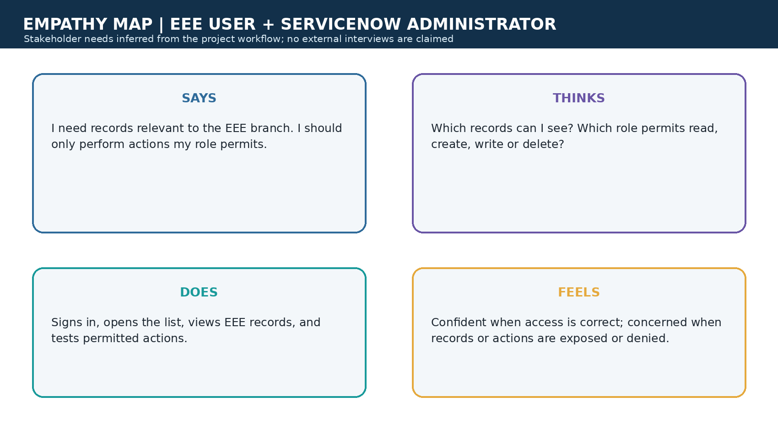
Figure 1. Project-specific empathy map canvas.

2.3 Brainstorming
The brainstorming process grouped ideas into data setup, access design, operation control and verification. The prioritized concept was a role- and field-aware ACL pattern: secure READ visibility first, then add least-privilege CRUD operations, and finally verify through impersonation.
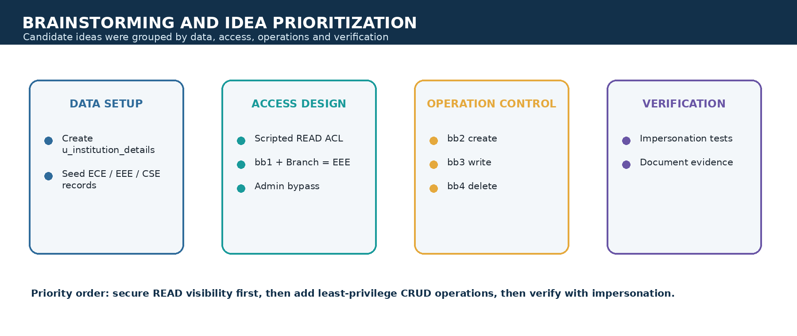
Figure 2. Project-specific brainstorming and prioritization.

3. REQUIREMENT ANALYSIS

3.1 Customer Journey map
The journey follows a user from sign-in through opening a list or form, ACL evaluation, the resulting allow/deny decision and visible feedback. The key pain points are overexposure, unclear permissions, inconsistent CRUD behavior and difficult verification.
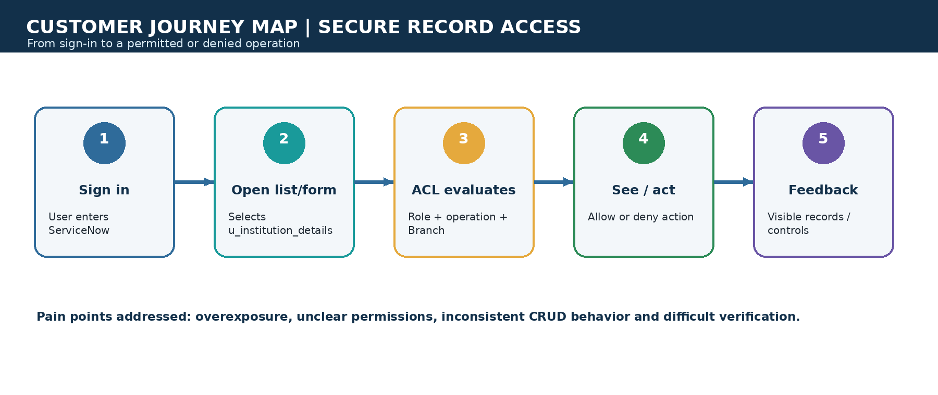
Figure 3. Customer journey map for secure record access.

3.2 Solution Requirement

Functional requirements
ID | Requirement
FR-1 | Create EEE User and custom roles bb1, bb2, bb3 and bb4; assign roles to the test user.
FR-2 | Create u_institution_details with Student Roll Number, Student Name, Faculty Name, Branch, Email, Phone Number and Description.
FR-3 | Allow administrators full access; allow bb1 users to read records where Branch is EEE; deny others.
FR-4 | Allow creation only when the create ACL requirement bb2 is satisfied.
FR-5 | Allow editing only when the write ACL requirement bb3 is satisfied.
FR-6 | Allow deletion only when the delete ACL requirement bb4 is satisfied.
FR-7 | Support impersonation and verification of list visibility and permitted actions.

Non-functional requirements
ID | Requirement | Description
NFR-1 | Usability | Access behavior is understandable in the ServiceNow list and form experience.
NFR-2 | Security | Enforce record-level access using roles, operation-specific ACLs, the Branch condition and administrator bypass.
NFR-3 | Reliability | Apply the same role and condition rules consistently whenever records are accessed.
NFR-4 | Maintainability | Keep permissions separated by operation and use named roles.
NFR-5 | Availability | Depends on the availability of the ServiceNow instance.
NFR-6 | Scalability | Platform-managed; independent scaling targets are not defined in the lab.

3.3 Data Flow Diagram
The data flow begins with a user and role context, passes through the ServiceNow interface and ACL engine, and reaches the protected table only when the role, operation and Branch checks allow the request.
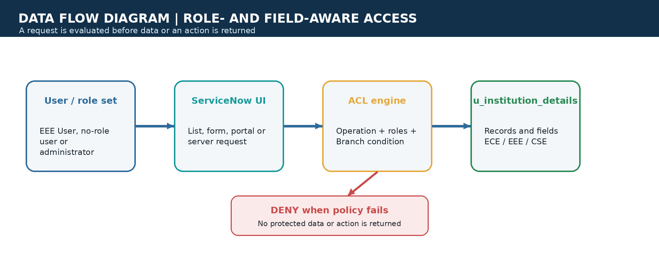
Figure 4. Data flow diagram for role- and field-aware access.

3.4 Technology Stack
Component | Technology | Purpose
User interface | ServiceNow UI (lists and forms) | Users access Student Records and permitted actions.
Application logic | ServiceNow ACL engine + server-side JavaScript | Evaluates role, operation and Branch conditions.
Security configuration | ServiceNow record ACLs | Separate READ, CREATE, WRITE and DELETE rules.
Administration | ServiceNow administration and impersonation | Creates users/roles and verifies behavior.
Database | ServiceNow table: u_institution_details | Stores student/institution and contact fields.
Infrastructure | ServiceNow hosted instance | Runs the application and platform data store.
External APIs / ML | Not used | No external API or machine-learning model is specified.

4. PROJECT DESIGN

4.1 Problem Solution Fit
The problem is frequent, security-sensitive and directly connected to the user experience: EEE users need relevant records without seeing other branches, while administrators need a complete management path. The ACL solution fits because it enforces access at the platform security boundary rather than relying on a visual filter.
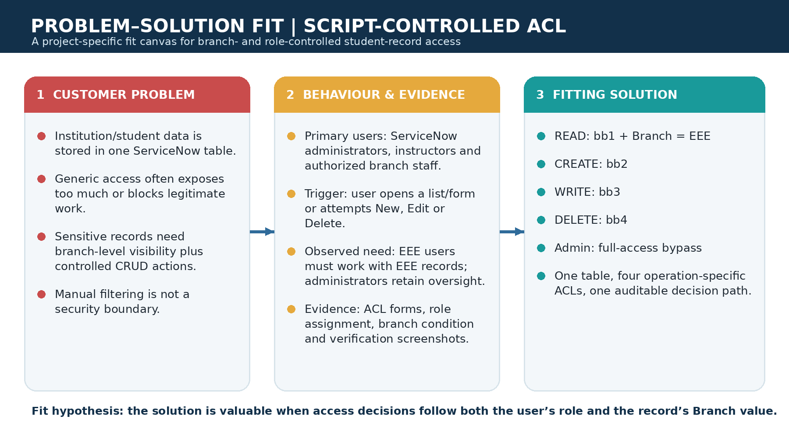
Figure 5. Problem–Solution Fit canvas.

4.2 Proposed Solution
Create u_institution_details, seed ECE/EEE/CSE records, create the EEE test user and custom roles, and configure four ACLs. The READ ACL uses bb1 with Branch = EEE and an administrator bypass. CREATE, WRITE and DELETE are controlled progressively by bb2, bb3 and bb4.
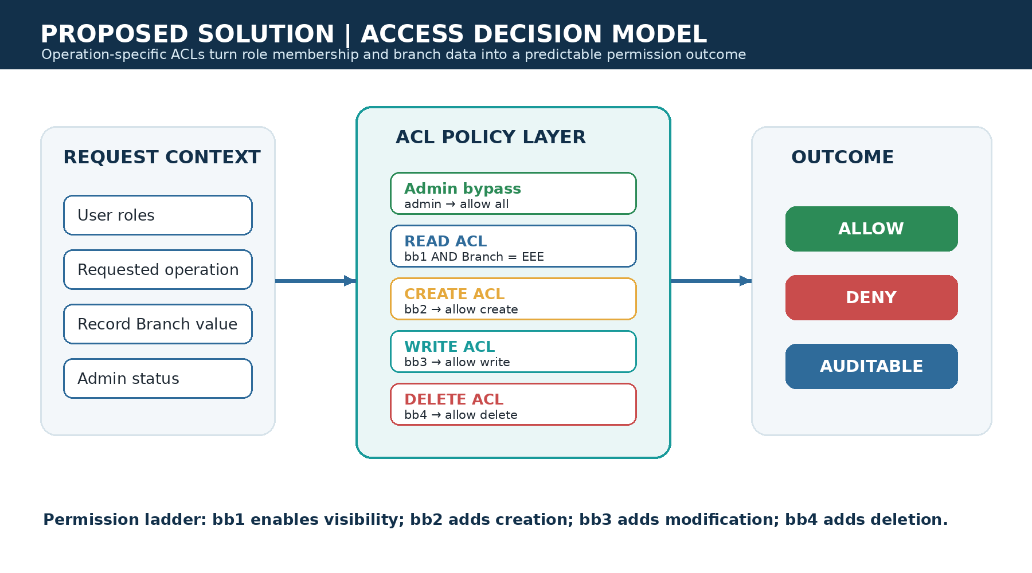
Figure 6. Proposed access decision model.
Operation | Role | Condition / outcome
READ | bb1 | Allow EEE records; administrator bypass allows all.
CREATE | bb2 | Allow creation for authorized role.
WRITE | bb3 | Allow editing for authorized role.
DELETE | bb4 | Allow deletion for authorized role.
Admin | admin | Full access across branches and operations.

4.3 Solution Architecture
The architecture uses ServiceNow as the platform boundary. Access channels submit requests; the ACL engine identifies the operation, checks role membership, evaluates the Branch condition where applicable, and returns an allow/deny result before data or an action is exposed.
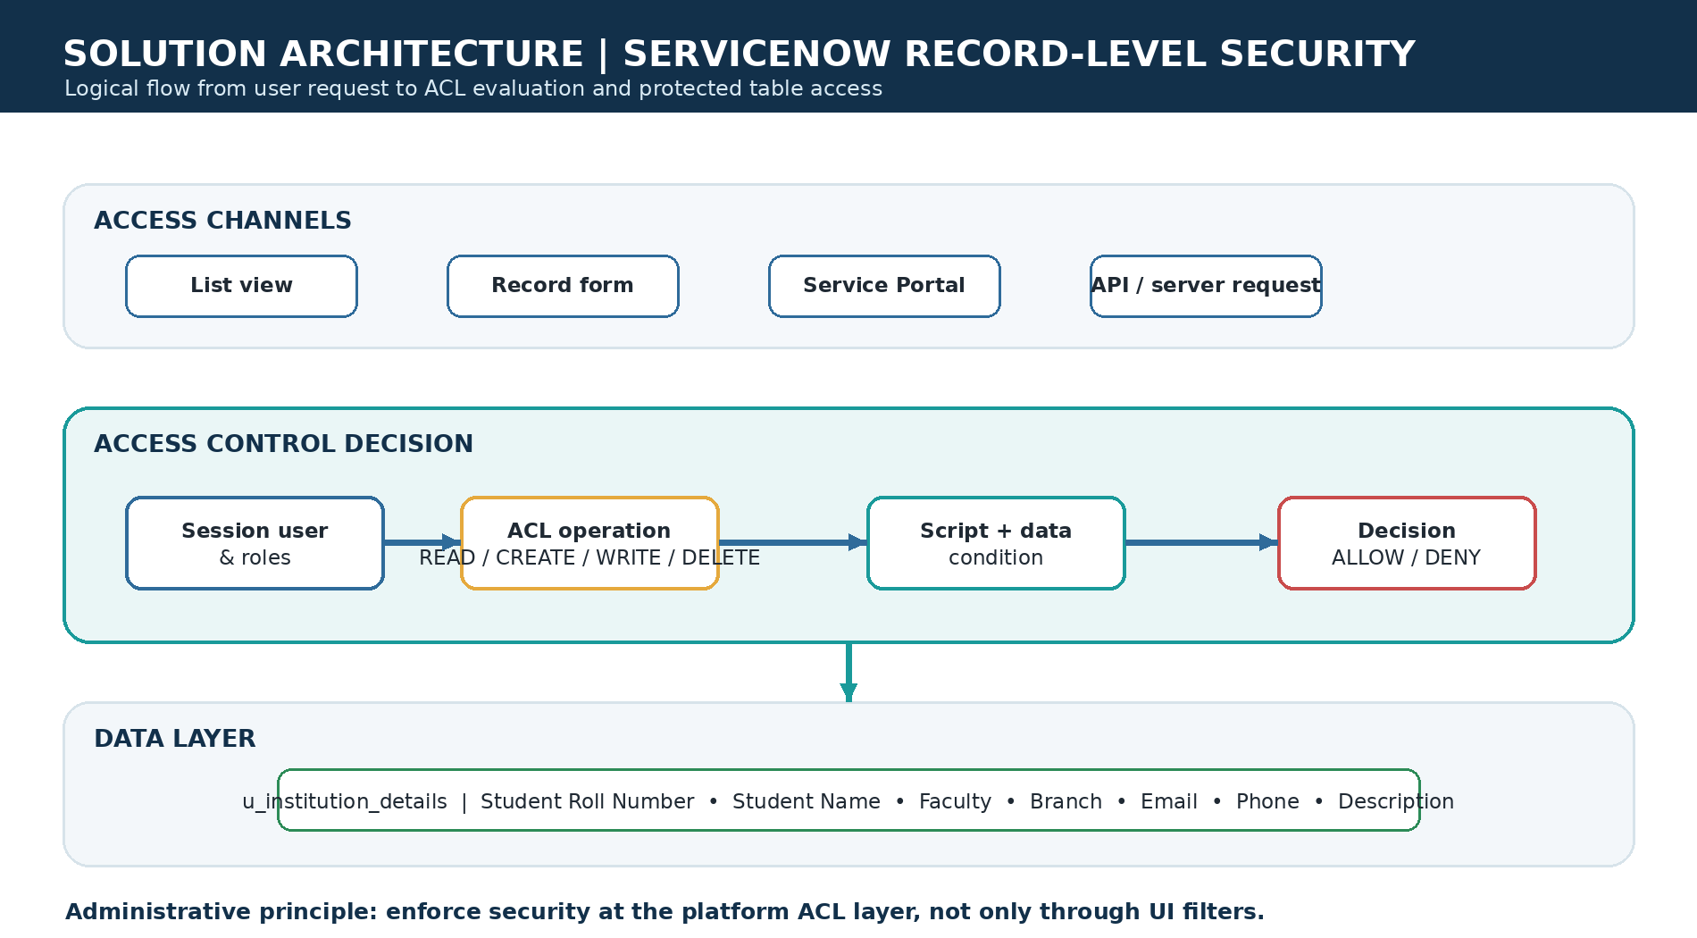
Figure 7. Solution architecture and authorization flow.

5. PROJECT PLANNING & SCHEDULING

5.1 Project Planning
The project was planned as three five-working-day sprints with a 28-point backlog. Sprint 1 establishes the table, fields, users and roles; Sprint 2 implements the ACLs; Sprint 3 performs verification, evidence capture and hardening. The planned average velocity is 28 ÷ 3 = 9.33 story points per sprint.
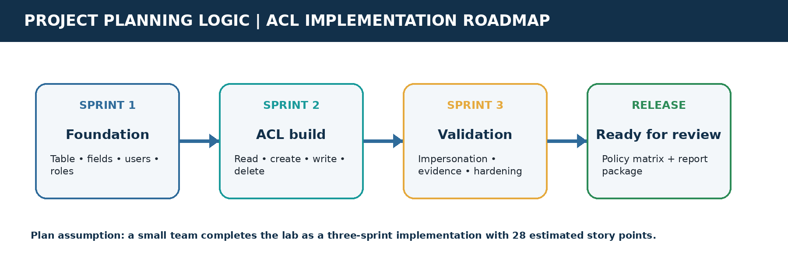
Figure 8. Project-specific sprint roadmap.
Sprint | Scope | Points | Planned dates
Sprint 1 | Data foundation and identity/role setup | 9 | 05–09 Oct 2026
Sprint 2 | READ, CREATE, WRITE and DELETE ACL implementation | 11 | 12–16 Oct 2026
Sprint 3 | Impersonation tests, evidence and hardening | 8 | 19–23 Oct 2026

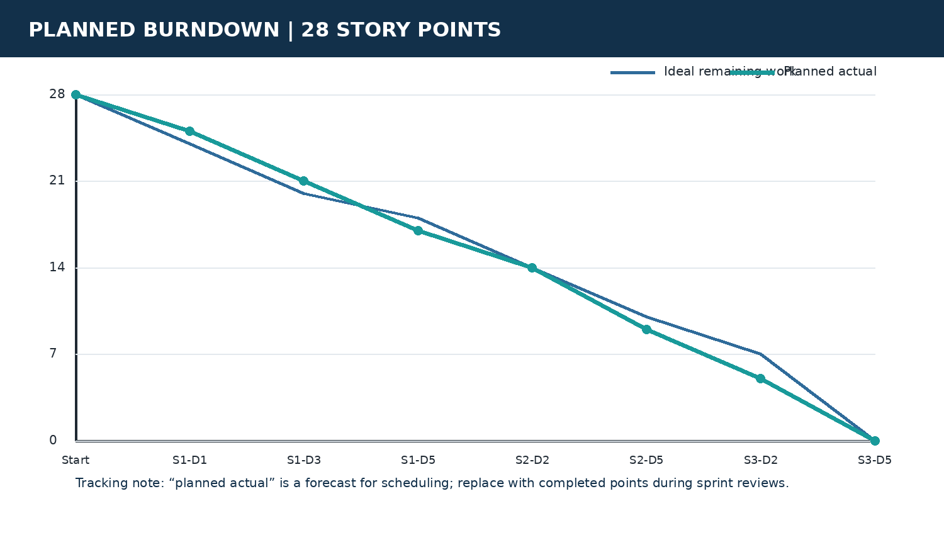
Figure 9. Planned burndown for the 28-point backlog.

6. FUNCTIONAL AND PERFORMANCE TESTING

6.1 Performance Testing
Functional testing covers role × operation × Branch combinations. Performance testing is defined for record volumes of 100, 1,000, 10,000 and 50,000 records; concurrency levels of 1, 10, 25 and 50 users; and a mixed operation profile of READ 60%, CREATE 15%, WRITE 15% and DELETE 10%. Measurements should include p50/p95 response time, throughput, error rate and authorization correctness.
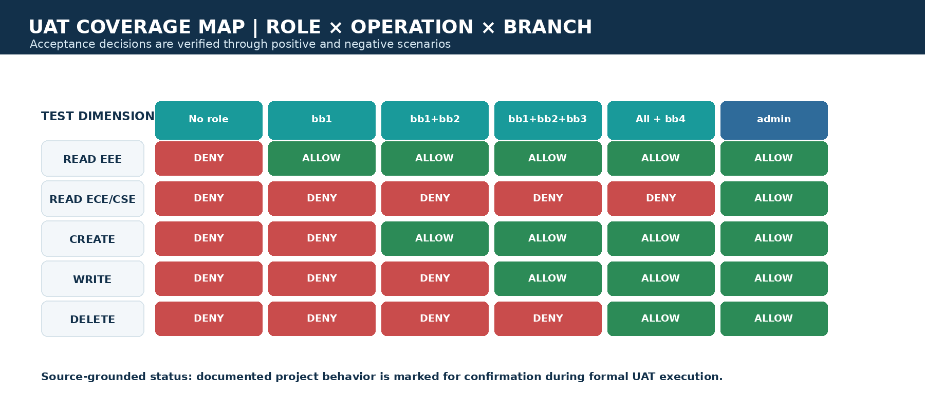
Figure 10. UAT coverage map for the ACL policy.
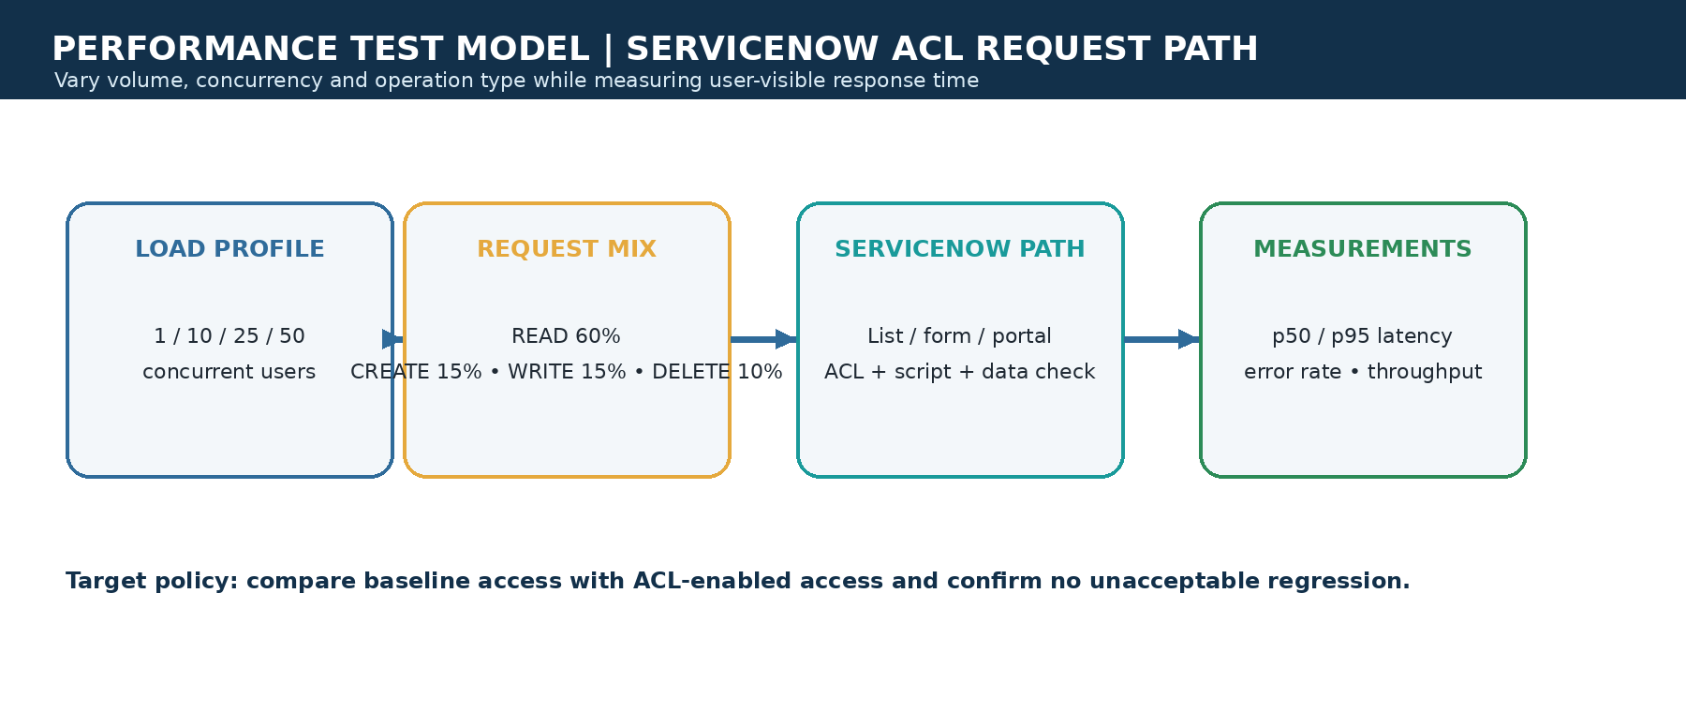
Figure 11. Performance-test model for the ServiceNow ACL request path.
Test area | Expected result | Status
Branch-level READ | bb1 user sees EEE records only; non-EEE records remain protected. | Documented in source; formal confirmation pending.
Role ladder | bb2 adds create, bb3 adds write, bb4 adds delete. | Documented in source; formal confirmation pending.
Admin bypass | Administrator can view and manage all branches. | Documented in source; formal confirmation pending.
Performance | ACL-enabled p95 response and error rate remain within agreed target. | Not measured in supplied project document.

7. RESULTS

7.1 Output Screenshots
The following screenshots are from the implemented ServiceNow project and show the table data, ACL script, operation-specific configuration and role/condition setup. They are evidence of configuration and documented behavior; formal UAT/performance execution should be completed in the target instance.

Institution Details list with branch records

Figure: Institution Details list with branch records

u_institution_details field configuration
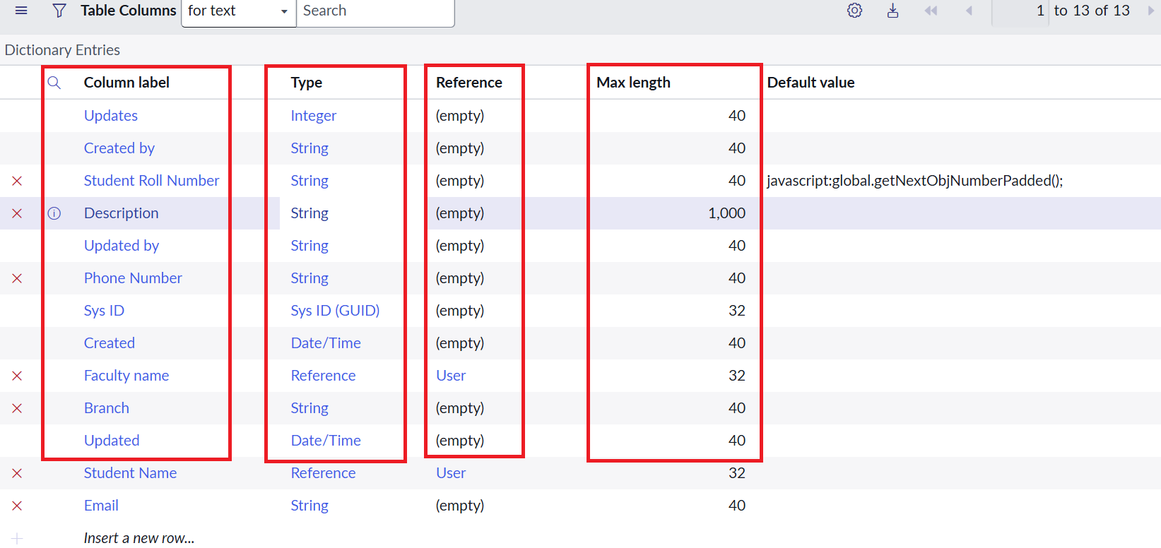
Figure: u_institution_details field configuration

READ ACL script and Branch condition

Figure: READ ACL script and Branch condition

Operation-specific ACL configuration

Figure: Operation-specific ACL configuration

Additional ACL operation configuration
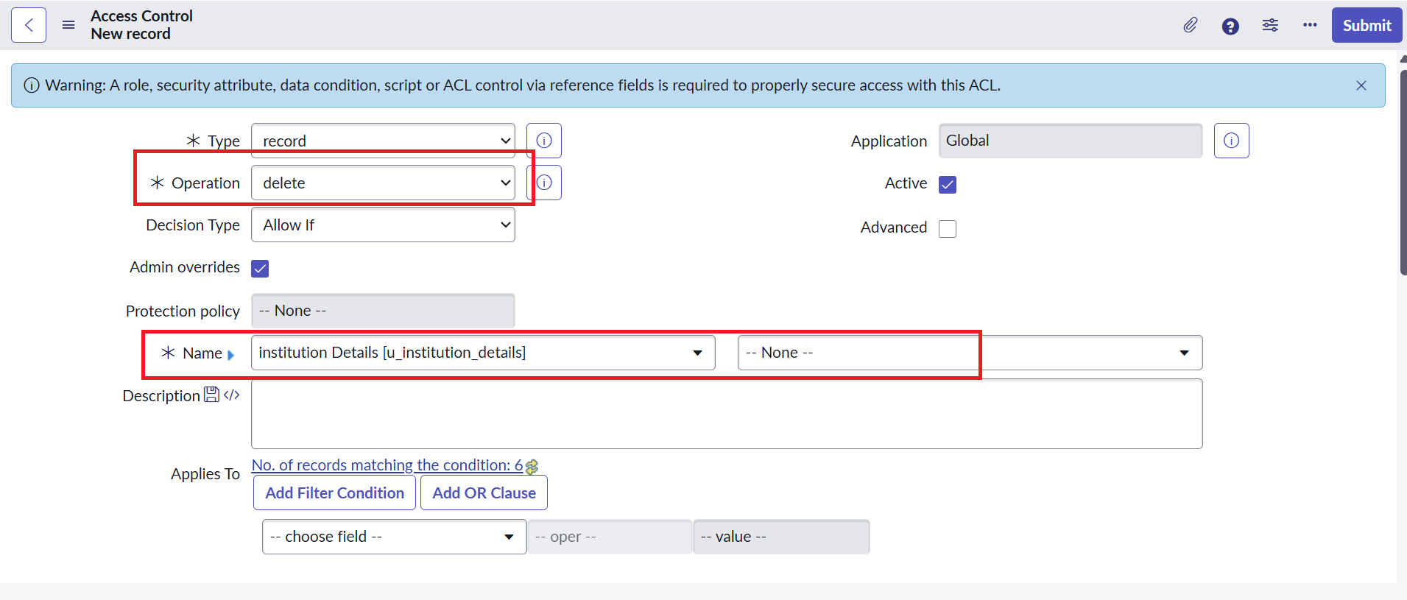
Figure: Additional ACL operation configuration

Role and operation configuration evidence
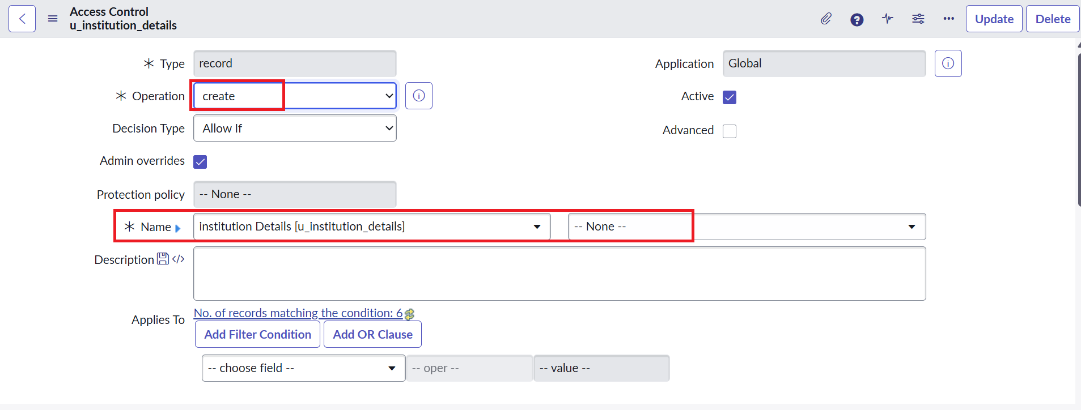
Figure: Role and operation configuration evidence

8. ADVANTAGES & DISADVANTAGES
Advantages | Disadvantages / limitations
Enforces access at the ServiceNow ACL layer instead of relying only on UI filters. | The lab depends on a configured ServiceNow instance and security_admin privileges.
Least-privilege role ladder separates read, create, write and delete. | The project does not define production latency, throughput or availability targets.
Branch-aware READ control protects records by field value. | Create/write/delete branch conditions may need additional policy refinement for production.
Administrator bypass supports operational support and testing. | Role assignment and impersonation must be governed carefully.
Reusable pattern for other tables and branches. | No external API, dataset repository, GitHub project or demo link was supplied.

9. CONCLUSION
The Script-Controlled ACL project demonstrates a platform-native approach to record-level security in ServiceNow. It combines user roles, operation-specific ACLs and a Branch data condition to produce explicit allow/deny decisions for institution records. The completed work spans problem definition, requirements, architecture, planning and testing preparation, while the supplied evidence shows how the ACL configuration is implemented and verified.

10. FUTURE SCOPE
- Extend branch-aware data conditions to CREATE, WRITE and DELETE when production policy requires complete branch isolation.
- Add automated ServiceNow ATF tests for every role, operation and branch combination.
- Introduce formal performance baselines and load tests using controlled data volumes and concurrency.
- Add audit reporting for ACL decisions, role changes and administrator impersonation sessions.
- Generalize the pattern into a scoped application or reusable policy framework for additional tables and branches.
- Integrate role provisioning with approved identity and governance workflows.
- Document production deployment, rollback, monitoring and security review procedures.

11. APPENDIX

Source Code (if any)
The project uses the following advanced READ ACL script in ServiceNow:
(function () {
// Allow admin users full access
if (gs.hasRole('admin')) {
return true;
}
// Allow only EEE branch users to see EEE records
if (gs.hasRole('bb1')) {
return true;
}
// Deny access for all others
return false;
})();
The READ ACL also applies the Branch = EEE data condition. CREATE, WRITE and DELETE use separate record ACLs with bb2, bb3 and bb4 requirements.

Dataset Link
Not applicable. The project uses test records created in the ServiceNow u_institution_details table; no external dataset link was supplied.

GitHub & Project Demo Link
Not provided in the supplied project documents. The implementation is described as running in a ServiceNow instance.

